|  |  |
| --- | --- |
| [Insurance Company] | Re: Patient Name: __________________________ |
| [Address Line 1] | Policy ID: __________________________ |
| [Address Line 2] | Policy Group: __________________________ |
|  | Date of Birth: __________________________ |

[Date]

Attn: [Medical/Pharmacy Director], [Department]

Re: Letter of CREXONT® (carbidopa and levodopa) Extended-Release CapsulesMedical Exception for [Plan Member Name]

Dear [Medical/Pharmacy Director]:

I am writing on behalf of my patient [patient’s name], who I saw on [date of visit]. [Patient’s name], a

[patient’s age]-year-old [male/female] patient, was diagnosed with Parkinson’s disease (PD) on [date]. Based on my clinical experience, I request a medical exception for my patient to receive CREXONT. [If pertinent, indicate how many years you have been treating patient.]

As a board-certified [internist/neurologist/movement disorder specialist/or other] and with my experience treating patients with PD, I have concluded that [patient’s name]’s current medication

[, medication name,] is no longer adequate considering their medical condition and history. Given their disease burden, continuing with the current treatment approach of using and increasing doses of step-through medications for PD [such as IR CD/LD] will not serve my patient's pressing medical needs. Therefore, I have concluded that treatment with CREXONT is medically necessary.

[If patient is taking IR CD/LD, add: Considering the short half-life and narrowing therapeutic window of IR CD/LD and the progress of my patient’s PD, even an increase in dose strength and frequency of IR CD/LD would be insufficient to control my patient’s symptoms and would likely lead to an increase in motor fluctuations and “Off” time with a marked decrease in quality of life. An increase in dose frequency may also put my patient’s medication adherence at risk, negatively impacting disease management.]1,2

[Describe clinical need, eg: In the past month, my patient has been experiencing debilitating “Off” time/wearing “off” periods/dyskinesia/other.]

[If indicating that patients are experiencing dyskinesia, add: Dyskinesia, motor complications that can develop over time with levodopa use, can be very debilitating for patients. Studies have shown that the short half-life of levodopa and increased dosing frequency as the disease progresses cause a pulsatile release of dopamine in the striatum that contributes to dyskinesia.]1,3

With a novel technology, CREXONT is unlike other oral CD/LD medications.4-6 It combines immediate-release granules and extended-release pellets and contains a novel mucoadhesive polymer designed to keep the ER pellet adhered to the area of absorption for longer to sustain LD plasma levels (exact site and duration of absorption are unknown).4,7

CREXONT is the longest-lasting oral CD/LD treatment currently available, as shown in a pharmacokinetic study vs RYTARY and IR CD/LD (based on the time that LD plasma levels were maintained above 50% of Cmax).4,8

The primary endpoint of this study was the pharmacokinetic profile9*†:

**Mean LD plasma level concentration-time profiles following a single dose of**

**CREXONT, RYTARY, and IR CD/LD in patients with advanced PD (n=24)8,9*†**

A post hoc analysis showed that LD plasma levels of CREXONT were sustained for longer than those of RYTARY or IR CD/LD (see data below).8,9

**Post hoc analysis of a prespecified secondary PK**

**parameter: duration with LD concentration >50% of Cmax9**

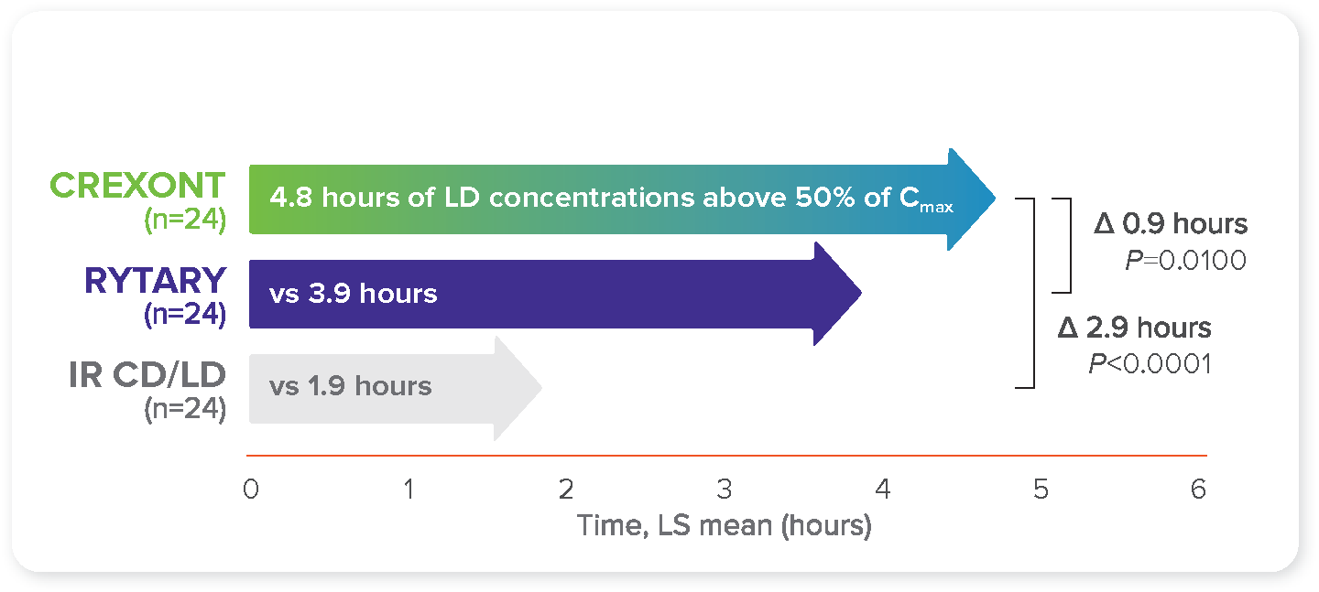

In a Phase 3, head-to-head study, CREXONT provided more "Good On" time with less frequent dosing vs optimized IR CD/LD.4,7‡

More “Good On” time and less frequent dosing are both important factors for my patient's ability to manage their medication regimen and control their symptoms.

CREXONT was compared with optimized IR CD/LD in the RISE-PD study, a Phase 3, randomized, double-blind trial. All patients started on IR CD/LD in a 3-week, open-label optimization period during which the dose could be adjusted to maximize therapeutic control. In a subsequent 4-week, open-label period, all patients converted from IR CD/LD to CREXONT to establish a stable therapeutic dose of CREXONT. Patients were randomized to receive double-blind CREXONT or their optimized dose of IR CD/LD, starting at the end of Week 7 (baseline).§ The primary endpoint was mean "Good On" time per day from baseline to end of study or early termination.4

Patients taking CREXONT experienced a statistically significant improvement in “Good On” time (0.5 hours per day) vs those taking optimized IR CD/LD (*P*=0.019).‖ Patients took CREXONT an average of 3 times per day vs an average of 5 times per day with optimized IR CD/LD.4,7,10

**“Good On” time per day4,7,10**

Secondary endpoint results included significantly less “Off” time (0.5 hours per day) with less frequent dosing with CREXONT vs optimized IR CD/LD (*P*=0.025).4,7¶

Additionally, in a post hoc analysis, CREXONT provided 1.6 more hours of “Good On” time per dose vs optimized IR CD/LD (*P*<0.0001).# This represented a 70% increase in “Good On” time per dose.4,9

CREXONT demonstrated a well-tolerated safety profile in a head-to-head study vs optimized IR CD/LD. Adverse reactions occurring at a higher rate in the CREXONT group than the IR CD/LD group during the double-blind maintenance period were nausea (4% vs 1%), anxiety (3% vs 0%), dizziness (2% vs 1%), dyskinesia (2% vs 0.4%), constipation (2% vs 0.4%), headache (1% vs 0%), vomiting (1% vs 0%), and insomnia (1% vs 0.4%).4,7

As can be seen from the study, CREXONT is an effective treatment that can provide patients with more "Good On" time per dose. In my clinical opinion, CREXONT will give my patient the most favorable efficacy and safety profile of the available treatments; and for these reasons, I have prescribed it for my patient.

In summary, I am requesting this medical exception because it is my professional judgment that it is medically necessary for [patient’s name] to receive CREXONT. Based on my patient’s clinical needs, I would consider it detrimental to their treatment if they were unable to receive CREXONT.

Please contact my office at [office phone number] if any additional information is required to ensure prompt approval for this course of treatment. Thank you for your serious consideration of this important medical exception.

Sincerely,

[Physician’s name]

[Reminder to list enclosures as appropriate (eg, excerpt(s) from patient’s medical record, relevant treatment guidelines, and product Prescribing Information).]

*The dose of IR CD/LD was the patient’s prestudy morning baseline dose, while the doses of CREXONT and RYTARY were chosen based on previous PK findings in healthy subjects. Assessment performed on patients in a

fasted and “Off” state. No LD plasma concentration values were available after the 8-hour time point in the IR CD/LD group because all patients in that group had been rescued by then.8,9

†Summary statistics for LD PK parameters by treatment, across all doses of CREXONT, IR CD/LD, and RYTARY, respectively: Cmax (mean ± SD): 3161 ± 1665 ng/mL, 2492 ± 1459 ng/mL, 2839 ± 1909 ng/mL; tmax (median   
[min–max]): 2.0 h (0.5–7.0), 1.0 h (0.5–2.5), 2.0 h (0.5–6.5); t1/2 (mean ± SD): 2.3 ± 0.9 h, 1.4 ± 0.3 h, 2.0 ± 0.7 h; AUCt (mean ± SD): 13,291 ± 7264 ng∙h/mL, 4879 ± 2631 ng∙h/mL, 10,467 ± 6771 ng∙h/mL; AUC0–∞ (mean ± SD): 16,734 ± 9759 ng∙h/mL, 5456 ± 2896 ng∙h/mL, 13,840 ± 8899 ng∙h/mL.9

‡“Good On” time is defined as “On” time without troublesome dyskinesia.4

§Dosing was based on the regimen established at the end of Week 7 for CREXONT and at the end of Week 3 for IR CD/LD. No new dose adjustments could be made during the double-blind maintenance period.4

‖0.5 hours per day is the LS mean difference*. P* value based on change from the end of Week 7 (baseline) to Week 20 (end of study or early termination), as assessed by the patient’s PD diary.4,7

¶Change in “Off” time from baseline to end of study (hours) for CREXONT: 4.0–4.2 (LS mean difference: 0.4) vs IR CD/LD: 4.0–4.8 (LS mean difference: 0.9). *P* value based on change from the end of Week 7 (baseline) to Week 20 (end of study or early termination), as assessed by the patient’s PD diary.4,7,9

#1.6 more hours per dose is the LS mean difference. “Good On” time per dose was defined as daily “Good On” time (hours) divided by the daily dose frequency in the subject's stable dose regimen, as determined at the end of the dose adjustment period for subjects randomized to IR CD/LD and at the end of the dose conversion period for subjects randomized to CREXONT.4

AUC0–∞=area under the curve extrapolated to time infinity; AUCt=area under the curve until the last observation time t; CD/LD=carbidopa/levodopa; Cmax=maximum observed plasma concentration; ER=extended-release; IR=immediate-release; LD=levodopa; LS=least squares; PK=pharmacokinetic; SD=standard deviation; t½=half-life; tmax=time to maximum concentration.

**References: 1.** Dhall R, Kreitzman DL. Advances in levodopa therapy for Parkinson disease: review of RYTARY (carbidopa and levodopa) clinical efficacy and safety. *Neurology*. 2016;86(suppl 1):S13-S24. **2.** Grosset KA, Reid JL, Grosset DG. Medicine-taking behavior: implications of suboptimal compliance in Parkinson's disease. *Mov Disord*. 2005;20(11):1397-1404. **3.** LeWitt P, Ellenbogen A, Burdick D, et al. Improving levodopa delivery: IPX203, a novel extended-release carbidopa-levodopa formulation. *Clin Park Relat Disord*. 2023;8:100197*.* **4.** Hauser RA, Espay AJ, Ellenbogen AL, et al. IPX203 vs immediate-release carbidopa-levodopa for the treatment of motor fluctuations in Parkinson disease: the RISE-PD randomized clinical trial. *JAMA Neurol*. 2023;80(10):1062-1069. **5.** SINEMET [package insert]. Whitehouse Station, NJ: Merck & Co., Inc.; 2020. **6.** Mittur A, Gupta S, Modi NB. Pharmacokinetics of Rytary®, an extended-release capsule formulation of carbidopa–levodopa. *Clin Pharmacokinet*. 2017;56(9):999-1014. **7.** CREXONT [package insert]. Bridgewater, NJ: Amneal Pharmaceuticals LLC; 2024. **8.** Modi NB, Mittur A, Rubens R, Khanna S, Gupta S. Single-dose pharmacokinetics and pharmacodynamics of IPX203 in patients with advanced Parkinson disease: a comparison with immediate-release carbidopa-levodopa and with extended-release carbidopa-levodopa capsules. *Clin Neuropharmacol*. 2019;42(1):4-8. **9.** Data on file. Amneal Pharmaceuticals LLC. **10.** Hauser RA, Espay AJ, LeWitt P, et al. A phase 3 trial of IPX203 vs IR CD-LD in Parkinson’s disease patients with motor fluctuations (RISE-PD). Presented at: American Academy of Neurology Annual Meeting; April 2-7, 2022; Seattle, WA, and virtual. S16.010.

CREXONT® is a registered trademark of Amneal Pharmaceuticals LLC.

© 2024 Amneal Pharmaceuticals LLC.

Distributed by Amneal Specialty, a division of Amneal Pharmaceuticals LLC.

All rights reserved. PP-HCP-IPX203-US-0011 08/2024